Launch4j and Inno Setup Guide
Objective
This document explains how to generate a Windows executable (.exe) using Launch4j and package it into a Windows installer (.exe) using Inno Setup.

Prerequisites
Before you begin, ensure the following software is installed:
- Java JDK (Java 25 or your project version)
- Maven or Gradle (depending on your project)
- WinRun4J
- Inno Setup Compiler
- Application JAR file
- Application icon (.ico)

Step 1: Build the Java Application
- Generate the executable JAR file. : mvn clean package
- The generated JAR will be available in: target/
- Example: activepulse-agent-1.0.0.jar

Step 2: Prepare the Application Folder
- Create a folder structure similar to:
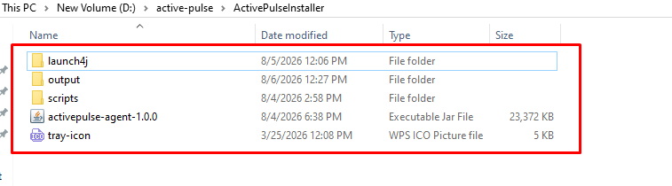

Step 3: Launch4j Configuration Steps
- Download WinRun4J
  - https://sourceforge.net/projects/winrun4j/files/winrun4j/?utm_source=chatgpt.com
  - https://sourceforge.net/projects/winrun4j/files/winrun4j/?utm_source=chatgpt.com
- Extract
  - After extraction you'll have
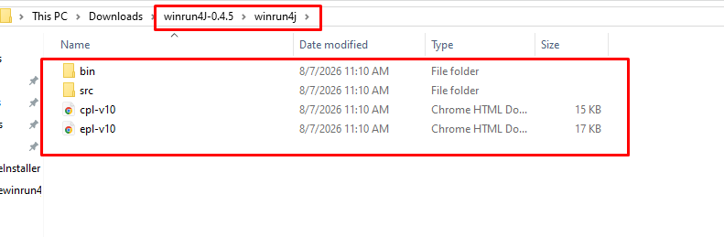
  - Open : bin
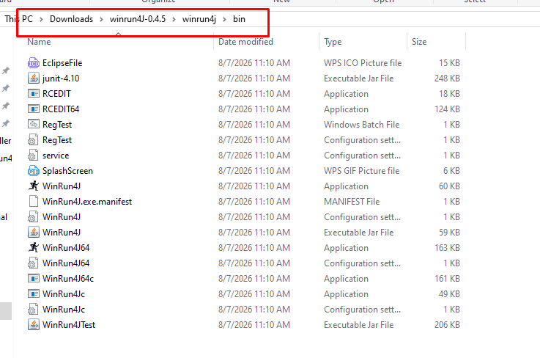
  - Choose Launcher
    - Since your users have 64-bit Windows, use : WinRunJ64.exe
    - Copy it to your application folder.
    - Rename WinRunJ64.exe to ActivePulse.exe
    - This executable becomes your application launcher.
- Create Folder Structure
  - Create the following structure:
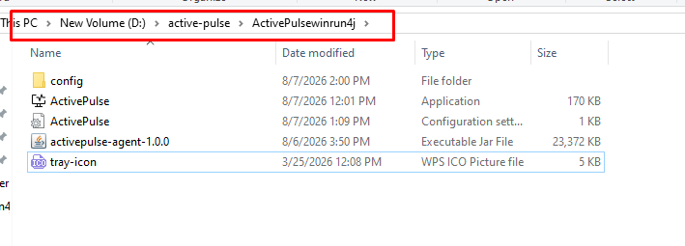
- Create ActivePulse.ini
  - Create ActivePulse.ini beside the EXE.
  - WinRun4J reads this INI automatically because it has the same name as the executable.
  - ActivePulse.ini code : (Update values as per you data/codebase)
main.class=com.activepulse.agent.Main
working.directory=.
classpath.1=activepulse-agent-1.0.0.jar
vm.location=C:\Program Files\Java\jdk-25.0.4\bin\server\jvm.dll
vm.version.min=25
vmarg.1=-Xms256m
vmarg.2=-Xmx1024m

- Test
  - Double-click : ActivePulse.exe
  - If everything is correct:
    - JVM loads
    - JAR starts
    - Application runs
- Inject Application Icon
  - Open Command Prompt.
    - Go to : winrun4j\bin
    - Run : RCEDIT64.exe /I D:\active-pulse\ActivePulsewinrun4j\ActivePulse.exe D:\active-pulse\ActivePulsewinrun4j\tray-icon.ico
    - You should see : [info] OK
    - This embeds the icon into the executable. The WinRun4J documentation recommends using RCEDIT/RCEDIT64 to inject the icon resource.
- Verify Icon
  - Check(File Explorer,Desktop shortcut,Start Menu shortcut,TaskManager)
  - If Windows still shows the old icon: Restart Explorer
- Test the EXE
  - Run : Start-Process "D:\active-pulse\ActivePulsewinrun4j\ActivePulse.exe"
  - Check :Get-Process ActivePulse

Step 4: Inno setup Configuration Steps
- Open Inno Setup
  - Open Inno Setup Compiler.
  - The Inno Setup Script Wizard appears.
  - Leave Create a new empty script file unchecked.
  - Click Next.
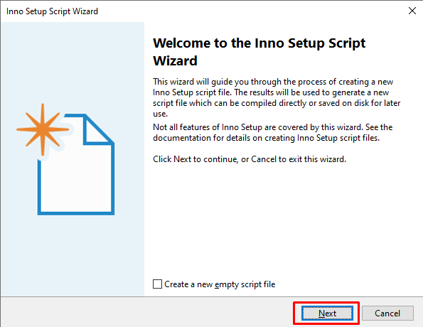
- Application Information
  - Enter your application details.
Field | Value
Application name | ActivePulse
Application version | 1.0.1
Application publisher | Your Company Name
Application website | Leave blank (or enter company website)
  - Click Next.
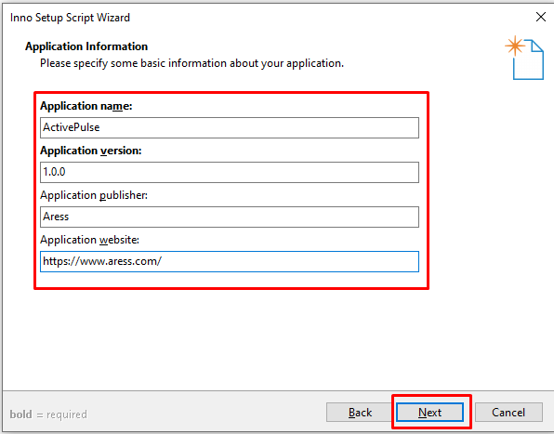
- Application Folder
  - Configure the installation folder.
    - Application destination base folder : Program Files folder
    - Application folder name : ActivePulse
    - Keep checked : Allow user to change the application folder
    - Do not select : The application doesn't need a folder
  - Click Next.
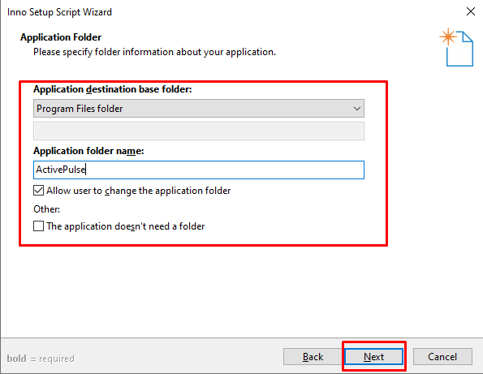
- Application Files
  - Application main executable file
    - Click Browse and select:ActivePulse.exe(Generated using Launch4j.)
    - Keep checked:Allow user to start the application after Setup has finished
  - Click Add Files...
    - ActivePulse.ini
    - activepulse-agent-1.0.0.jar
  - Click Next.
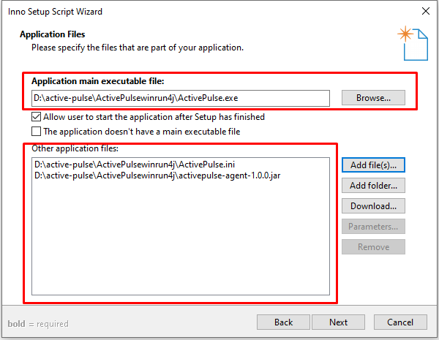
- Application File Association
  - Uncheck : Associate a file type to the main executable
  - Leave everything else blank.
  - Click Next.
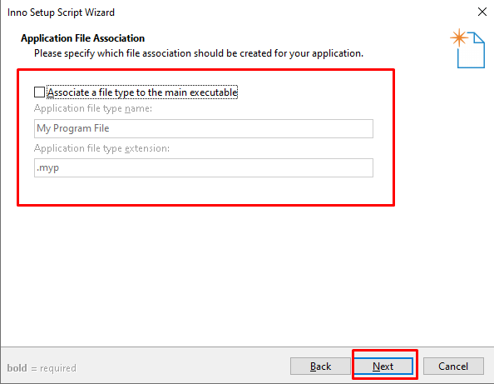
- Application Shortcuts
  - Keep checked:
    - Create a shortcut to the main executable in the Start Menu Programs folder
    - Allow user to create a desktop shortcut
  - Leave other options unchecked.
  - Click Next.
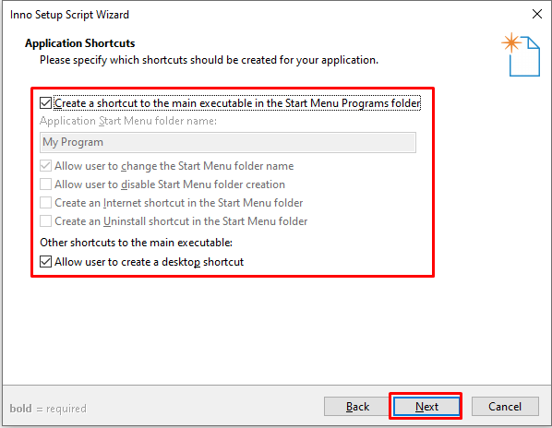
- Application Documentation
  - Leave all fields blank.
    - License file
    - Information file shown before installation
    - Information file shown after installation
  - Click Next.
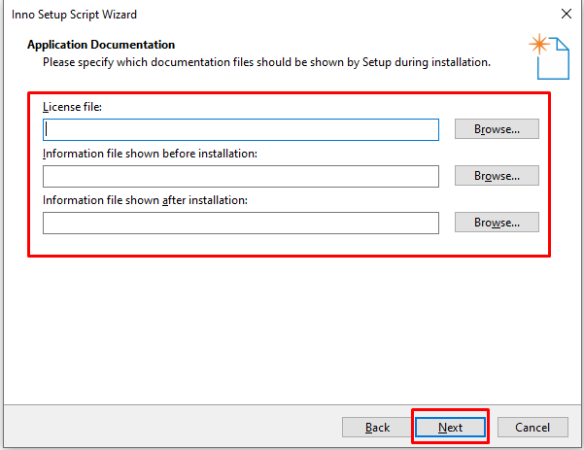
- Setup Install Mode
  - Select:Administrative install mode (install for all users)
  - Leave the remaining options unchecked.
  - Click Next.
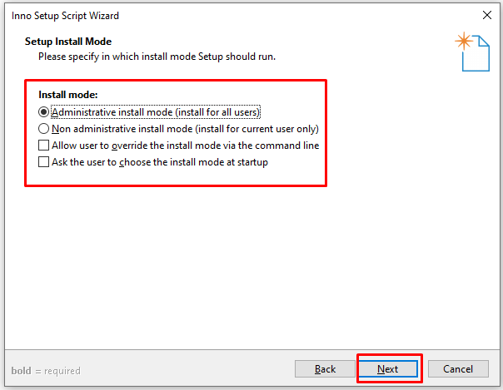
- Application Registry Keys and Values
  - Leave the registry file field blank.
  - Keep the default options:
    - Delete keys which are empty on uninstall
    - Delete values on uninstall
  - Leave all other options unchecked.
  - Click Next.
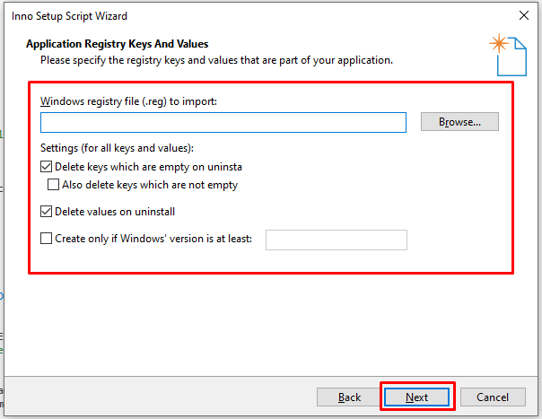
- Setup Languages
  - Select:English
  - Uncheck any other languages if selected.
  - Click Next.
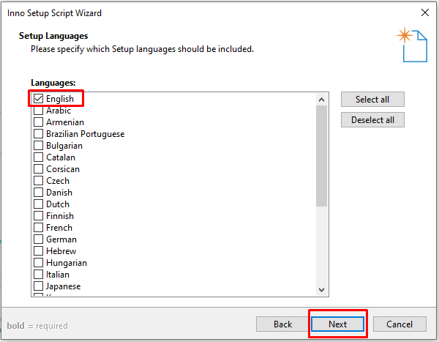
- Compiler Settings
  - Custom compiler output folder
    - Select the folder where the installer will be generated.
    - Example:D:\Release\Installer
  - Compiler output base file name
    - Example:ActivePulse-1.0.0
  - Custom Setup icon file
    - Browse and select : ActivePulse.ico
  - Setup password
    - Leave blank.
  - Click Next.
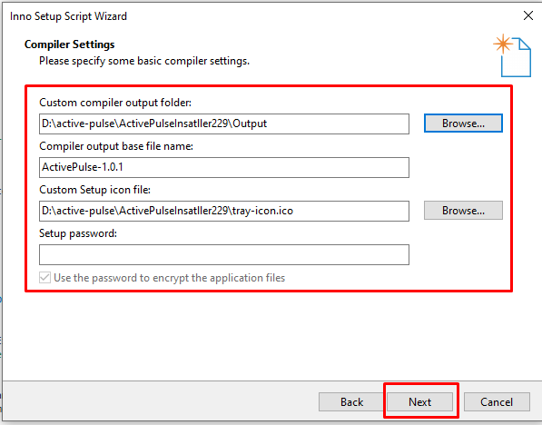
- Wizard Style
  - Keep the default values:
Setting | Value
Wizard style | Modern
Appearance | Dynamic
Theme | Default
  - Click Next.
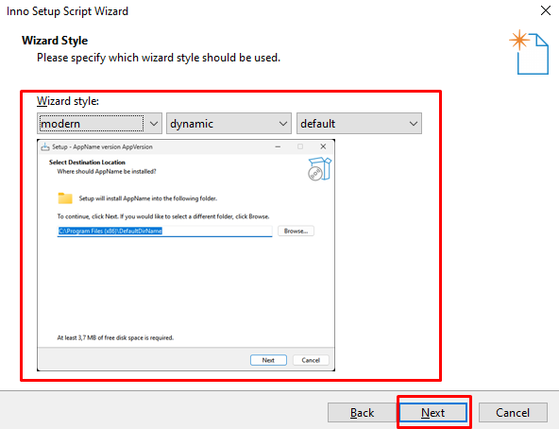
- Inno Setup Preprocessor
  - Keep checked:Yes, use #define compiler directives
  - Click Next.
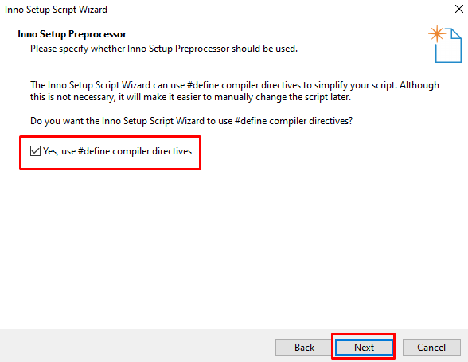
- Finish Wizard
  - Click Finish.
  - The wizard generates the .iss script.
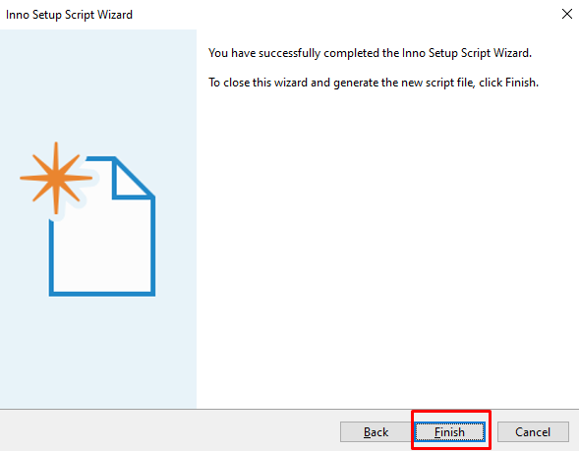
- Compile the Installer
  - In the Inno Setup Compiler, click:Build → Compile
  - or press:ctrl+f9
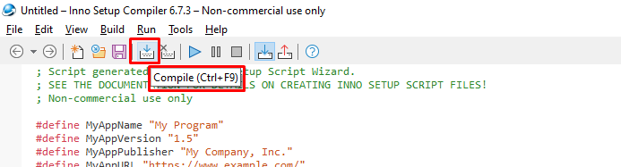
- Output
  - The installer will be created in the output folder you selected.
  - Example:D:\active-pulse\ActivePulseInsatller229\Output\ActivePulseSetup.exe
- Install and Test the Installer
  - Using Command Prompt
    - Open Command Prompt as Administrator.
    - Navigate to the downloaded ActivePulseAgent folder.
    - Run one of the following commands.
      - Silent Installation (Without Installation Logs) :
        - ActivePulseSetup.exe /VERYSILENT /SUPPRESSMSGBOXES /NORESTART
      - Silent Installation (With Installation Logs) :
        - mkdir logs
        - ActivePulseSetup.exe /VERYSILENT /SUPPRESSMSGBOXES /NORESTART /LOG="logs\ActivePulseInstall.log"
  - Using PowerShell
    - Open PowerShell as Administrator.
    - Navigate to the downloaded ActivePulseAgent folder.
    - Run one of the following commands.
      - Silent Installation (Without Installation Logs) :
        - .\ActivePulseSetup.exe /VERYSILENT /SUPPRESSMSGBOXES /NORESTART
      - Silent Installation (With Installation Logs) :
        - New-Item -ItemType Directory -Path .\logs -Force
        - .\ActivePulseSetup.exe /VERYSILENT /SUPPRESSMSGBOXES /NORESTART /LOG="logs\ActivePulseInstall.log"
  - Post-Installation Verification
    - Application is installed at:C:\Program Files (x86)\ActivePulse
    - Application logs are generated successfully.
    - Activity tracking is working as expected.
    - The ActivePulse agent is running in Task Manager.

Step 5: Deployment Guide – Upload Latest ActivePulse
- Objective
  - Deploy the latest ActivePulse installer to the download portal and update the download link so users can download the newest build.
- Login to CWP Control Panel
  - Open the following URL in your browser:https://44.221.252.71:2083
  - Enter your credentials and click Login.
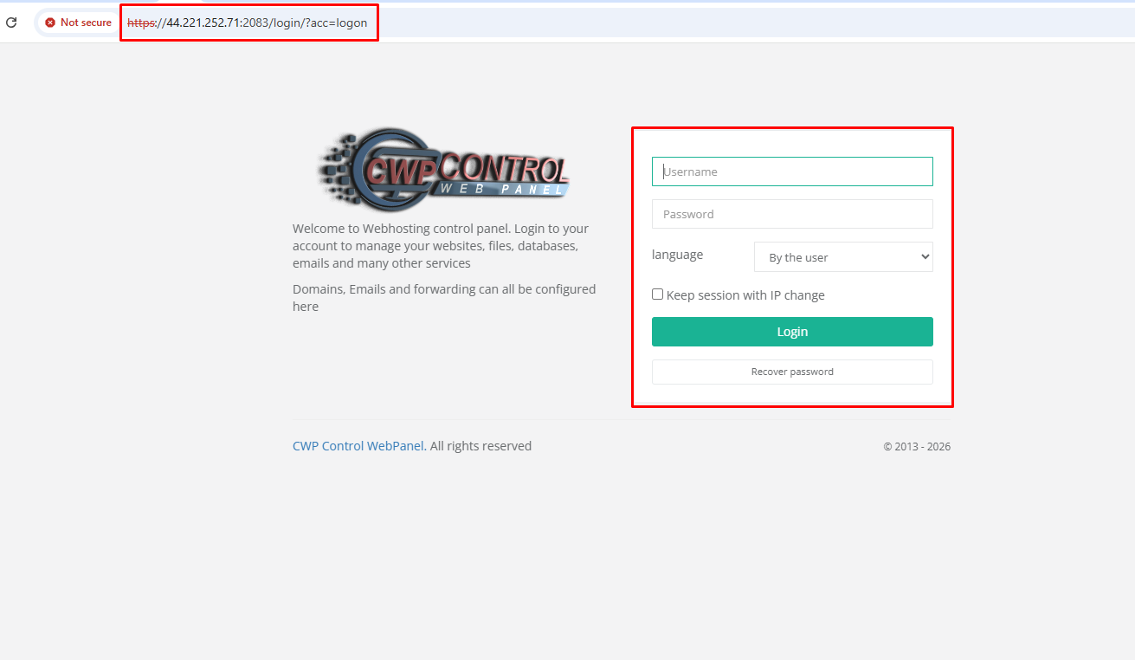
- Open File Manager
  - After logging in:
    - Click File Management from the left navigation menu.
    - Click File System Lock (if required).
    - Open File Manager.
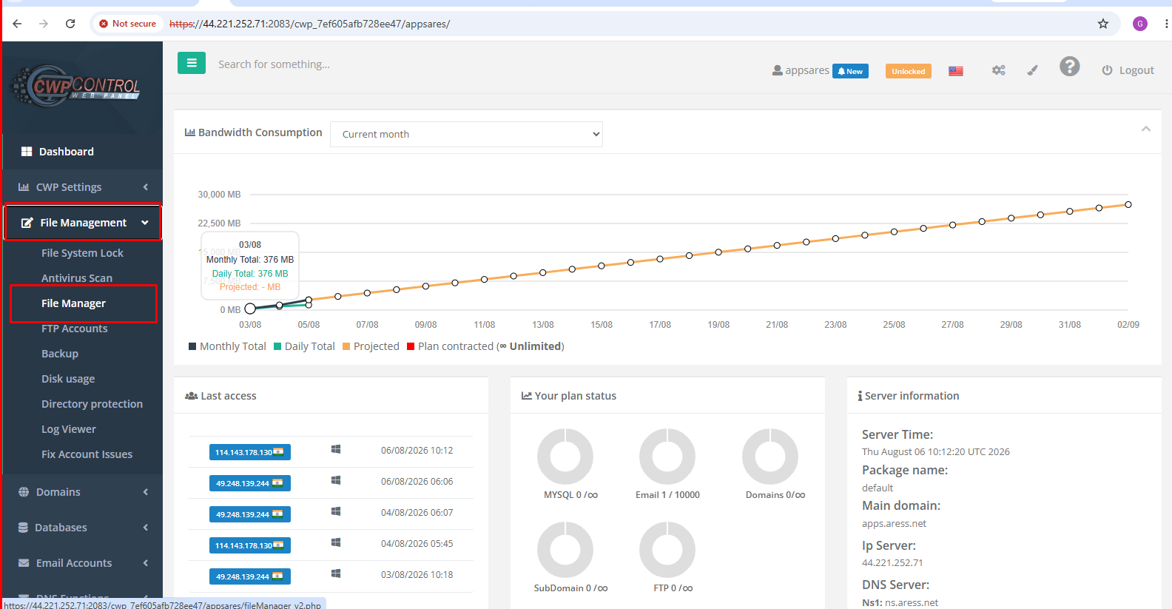
- Navigate to the ActivePulse Folder
  - In File Manager, navigate to:public_html ──> ActivePulse2.0
  - This folder contains:
    - ActivePulse installers (.exe, .msi, .dmg, .deb)
    - index.html
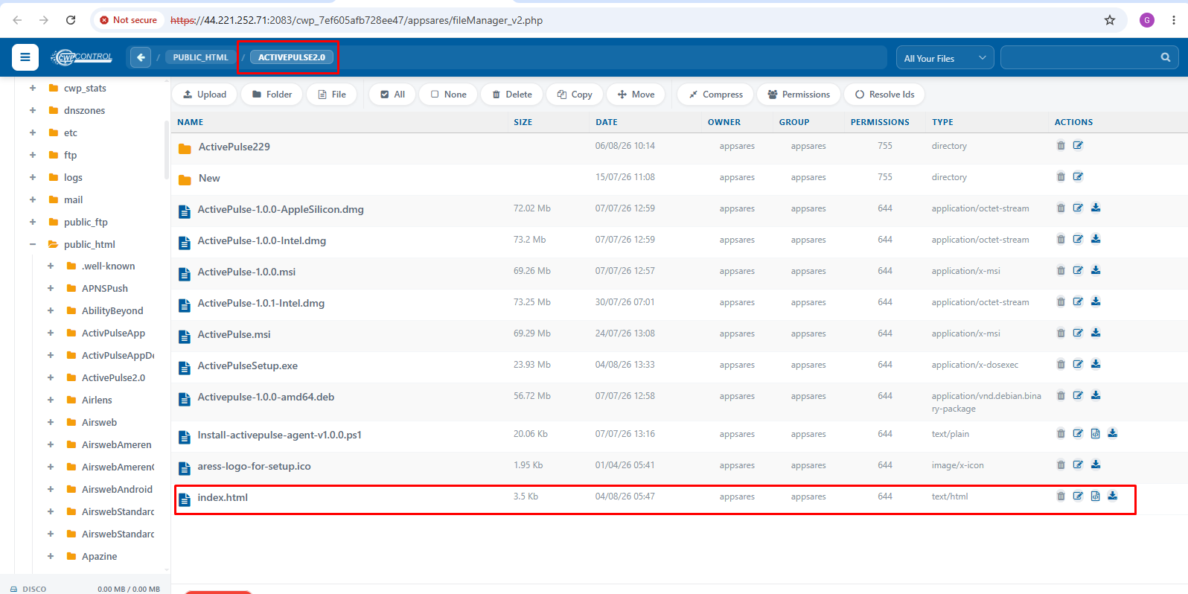
- Upload the Latest Build
  - Open the ActivePulse2.0 folder.
  - Click Upload.
  - Select the latest installer generated from Inno Setup.
  - Wait until the upload completes successfully.
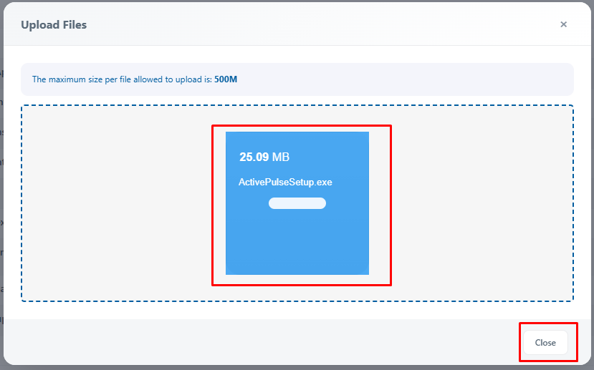
- Update the Download Link
  - After uploading the latest installer:
    - Locate index.html.
    - Click the Edit (pencil) icon.
    - Open the file in the editor.
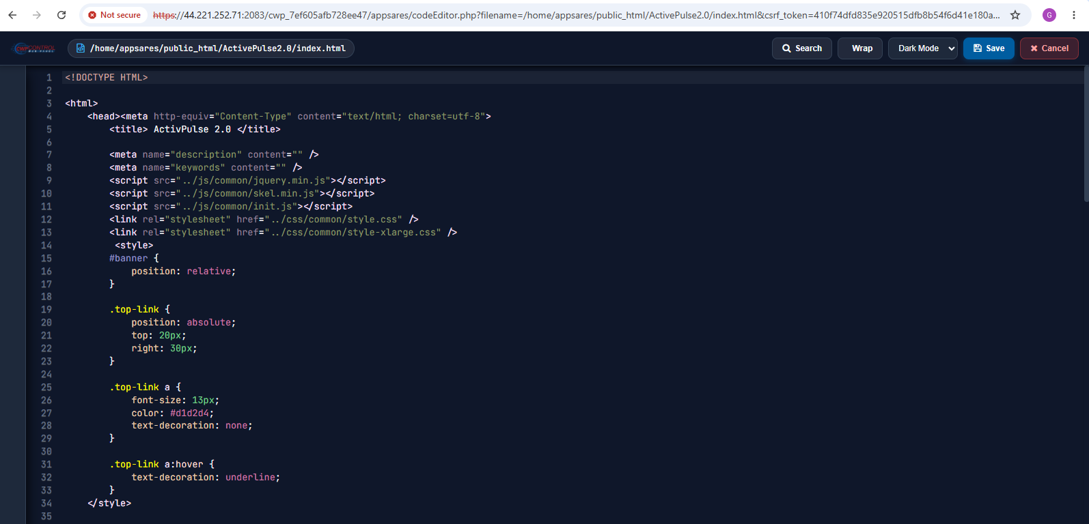
- Update the Installer Name
  - Find the existing installer filename.
  - Replace it with the latest uploaded filename.
  - Only update the filename.
  - Do not modify any other HTML code.
- Save the Changes
  - Click:Save
  - Wait until the file is saved successfully.
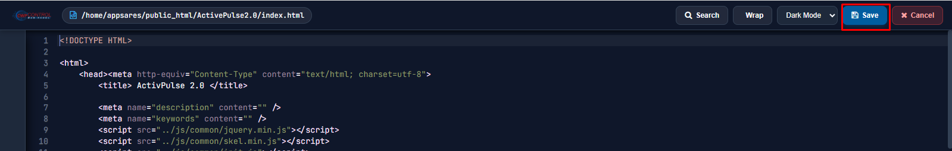
- Verify the Deployment
  - Open the download page in your browser:https://apps.aress.net/ActivePulse2.0/
  - Verify that:
    - The page loads successfully.
    - The Download button is visible.
    - Clicking the Download button downloads the latest installer.
    - The downloaded file matches the latest uploaded build.
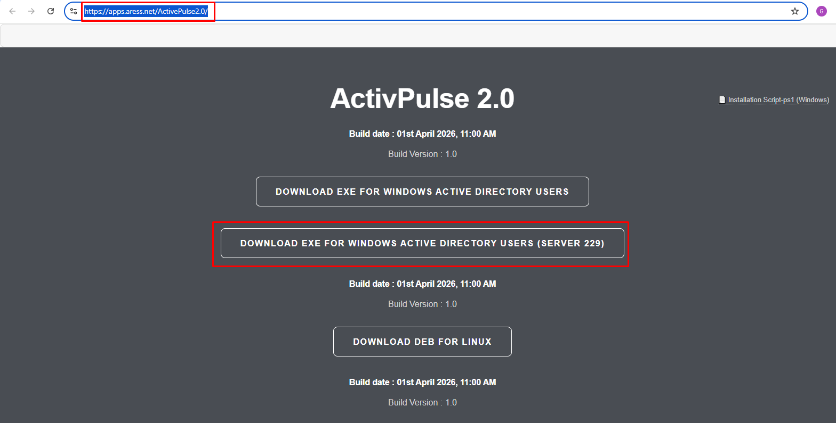
Troubleshooting
If the Icon Still Doesn't Change
Sometimes RCEDIT updates the executable resources but Windows continues showing the old icon because of icon cache or because the embedded icon group wasn't replaced as expected.
Use Resource Hacker to replace the executable's icon resources directly.
- Install Resource Hacker.
- Open : ActivePulse.exe
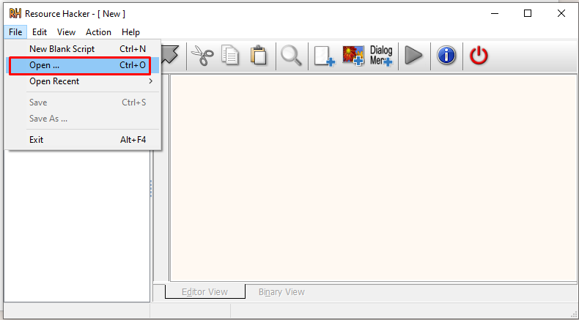
- Expand : Icon Group
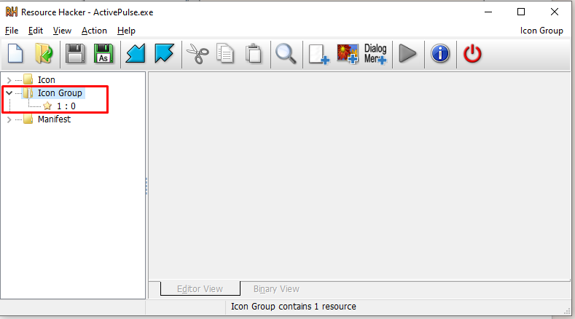
- Right-click the icon group. : Replace Icon…
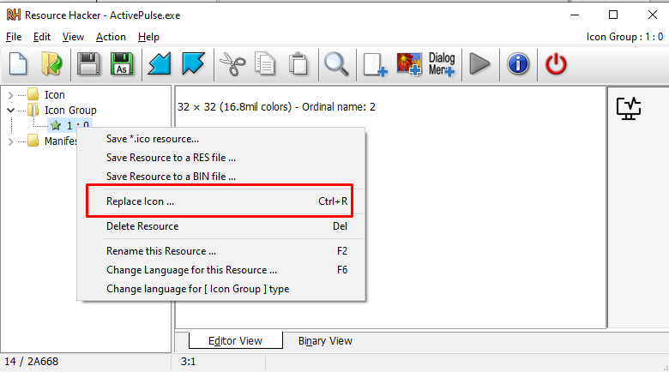
- Click : Open file with new icon
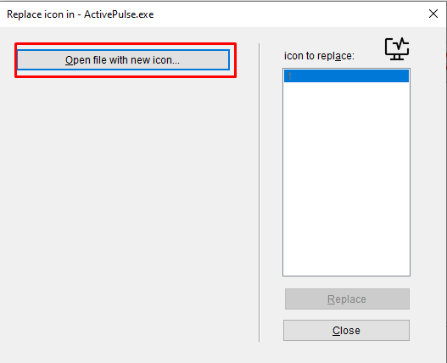
- Select : tray-icon.ico
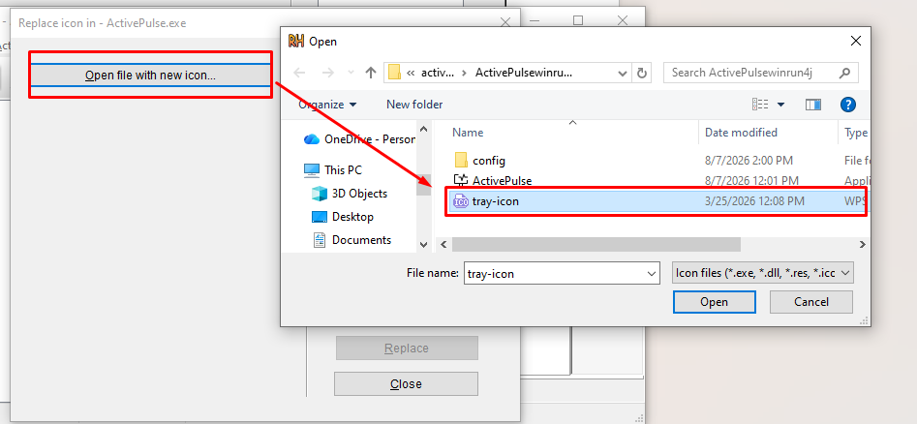
- Select the existing icon group. : Replace
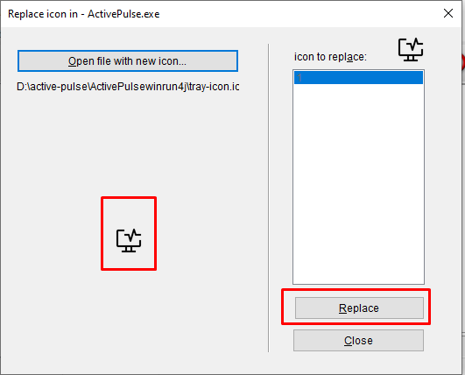
- Save the executable.
- if Windows still shows the old icon :simply restart Windows.

